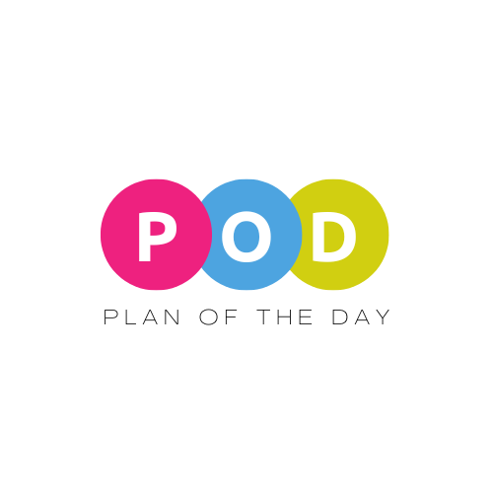
The Plan of the Day (POD) Accessibility Statement
Effective Date: 2025
The Plan of the Day (“POD”) is committed to ensuring that our website, services, and digital content are accessible to all individuals, including those with disabilities. We believe in equal access to information, tools, and resources, and we strive to follow accessibility best practices.
1. Our Commitment
We are dedicated to providing an inclusive and accessible experience for all visitors. Our goal is to conform to the Web Content Accessibility Guidelines (WCAG) 2.1 Level AA wherever possible.
2. Measures We Take
- Regularly review our website and content to identify and fix accessibility barriers.
- Provide text alternatives for non-text content.
- Ensure that our site is navigable via keyboard for users who cannot use a mouse.
- Maintain sufficient color contrast for readability.
- Avoid relying solely on color to convey meaning.
3. Ongoing Efforts
We view accessibility as an ongoing process and will continue to make improvements as standards evolve and technology changes.
4. Known Limitations
While we strive for full accessibility, some content or features may not yet meet our standards. We are actively working to improve these areas.
5. Feedback & Assistance
We welcome your feedback on the accessibility of POD. If you encounter any barriers or need assistance, please contact us:
📧 hello@theplanoftheday.com
🌐 www.theplanoftheday.com
We aim to respond to feedback within 3 business days and will work with you to find an accessible solution.
6. Third-Party Content
Our website or communications may contain links to external sites that are not fully accessible. We are not responsible for the accessibility of third-party content but will provide alternative access to important information whenever possible.
Thank you for helping us create an inclusive experience for everyone.

